Optical Character Recognition project (OCR)

# Project description

Develop a C# program for a multilayer perceptron that will be used in OCR. The input to this network is an image of a digit number (from 0-9) and the network should output which number is this.

* The training set is an ASC file “DIGITS.ASC” for the numbers with different fonts.  
   Examples of digits from the training set:

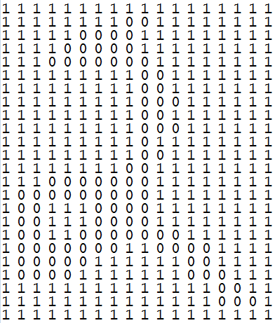 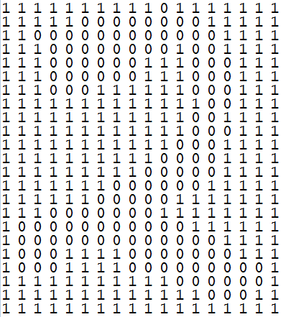

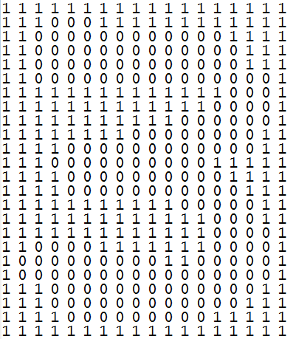 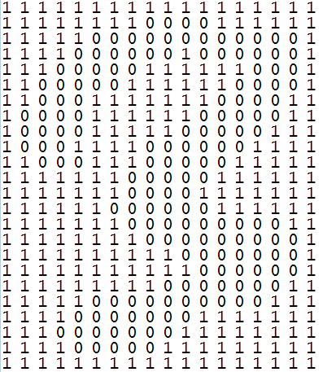

* The image of a digit in the training set is represented by 24 rows 18 columns. (So, how many inputs to the MLP?)
* The desired (target) is also an ASC file “digitsTarget.asc”. Each row in the digitsTarget.asc corresponds to a digit in the DIGITS.ASC file. If the digit in DIGITS.ASC is for the number ONE, then the corresponding row in digitsTarget.asc is 1000000000, if the digit was for the number two, the corresponding row is 0100000000… and so on. (So, how many neurons in the output layer?)
* The program should be scalable so that you can make trials on different numbers of hidden layers and different numbers of neurons in each hidden layer, until you get the best results.
* You should approximate the result of each output neuron either to 0 or 1, so that it is easier for you to compare with the digitsTarget.asc file.
* There is bonus on the GUI (example: taking the network values from user including number of hidden layers, learning rates… or using something like a wizard…)